Zach Wilson and McKeegan Curran-Seijo

Dr. Deepali

CIS 475-01

20 April, 2023

Lab Assignment 2

For this assignment, we made a website ([hosted by Keegan](http://98.215.98.126:3000/users)) that linked to our backend MySQL server. The site utilizes HTML, CSS, Node.JS and PHP to bring everything together. We have 5 pages on the site as you can see on the navbar at the top, one for each table in our database. Each page allows us to, insert, view, and remove data from the respective table. The database is currently structured such that we have 5 tables: Authors, Publishers, Books, BookLoans, and LibraryMembers. The Authors and Publishers tables have a one-to-many relationship with the Books table. The Books table has a one-to-many relationship with the BookLoans table and finally, the LibraryMembers table has a one-to-many relationship with the BookLoans table. You can see this in Figure 1 which is the entity relationship diagram for our database.

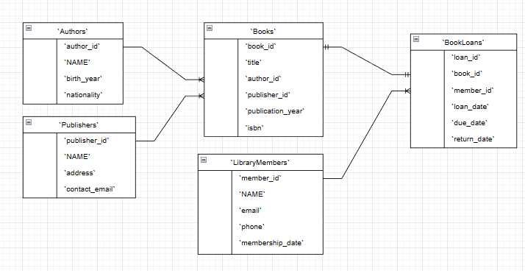

Figure